


INDIVIDUAL ASSIGNMENT

LANKA

COMP40004

WEB DEVELOPMENT AND OPERATING SYSTEMS-1
COMK2421, COMK2422

HAND OUT DATE: 18th March 2024

HAND IN DATE: ASSIGNMENT2: 24th May 2024

WEIGHTAGE: ASSIGNMENT 2: 30%

INSTRUCTION TO CANDIDATES:

- Students are advised to underpin their answers with the use of references (cited using the Harvard Name System of Referencing).

- Late submission will be awarded zero (0) unless Extenuating Circumstances (EC) are upheld.

- Cases of plagiarism will be penalized

- Assignment presentation should be submitted in the form of softcopy and hardcopy both; modeling work should be submitted in softcopy form
Student Details:

Name: Swasthika Lingaraj
CB Number: CB014540
Batch: COMK2421
GitHub Link:
Table of Contents

- Procedure of the project

- Challenges faced

- Wireframes

- Learning Outcomes of the project
Procedure of the project

I started the assignment by referring through the lecture notes provided and some youtube videos. They helped me a lot to get an overall idea about how
I am supposed to start and finish this assignment meeting the requirements.

Firstly I began designing the homepage for which I got the help of a random youtube video and started coding for the navigation bar of my homepage.

And then I started designing cover images for each type of products of my grocery store through Canva.

Once I was done with that I moved onto implementing the navigation sections and the footer sections for each page of my website. Afterwards I began working on the logo for which I used Canva.

After going through a lot of designs that would go well with the name I’ve chosen for my website I came up with the final logo.

Selecting pictures when required in every section of my website was a challenging task since the image dimensions didn’t always go with the structure of my webpage but hopefully I managed resizing them using a web app named iLoveIMG.

Nextly I started coding the body part of the other pages of my website for which I had to refer a lot of youtube tutorials , self-studying and researches.

Afterwards I began working on the css stylings, according to the way how I wanted my webpages to look like.

While working on these I uploaded my website to GitHub and then continued with the remaining work.

Once I finalized that this is how my my entire website is going to look like I started designing the wireframes for each page using Figma.

After completing all of the above mentioned I started writing my report for this individual assignment of mine.

Challenges faced

- Since this is my first time designing a website I didn’t have a proper idea about where should I start from which was a major challenge I had to overcome.
- Wrote down the assignment requirements and then started referring videos in the internet.
- Next it was about the errors I had to go through while coding
- Rechecked the code and found out the mistakes
Such as:
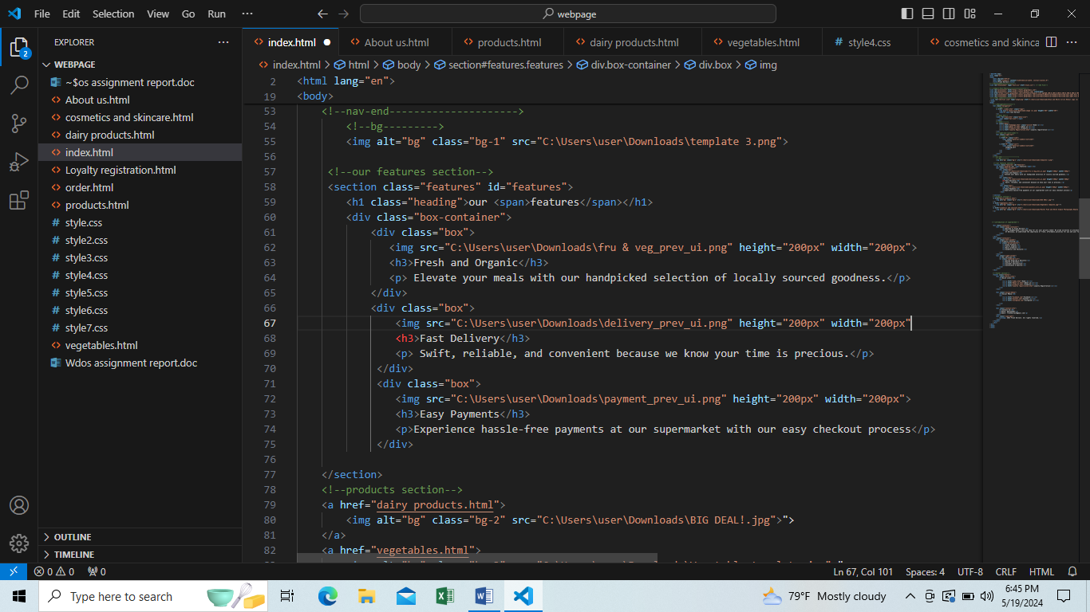Missing angular brackets
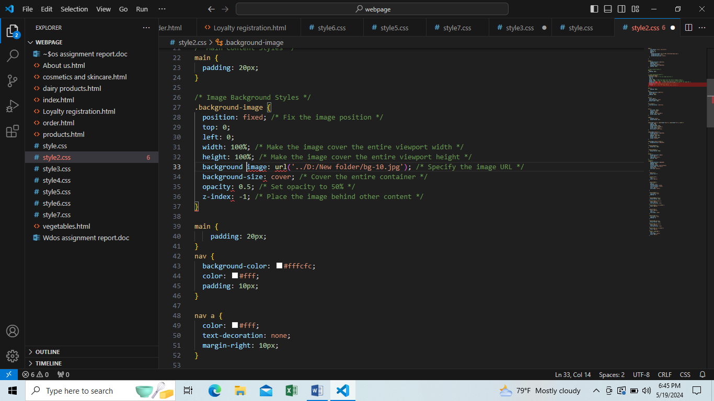 Missing hypen in background image command
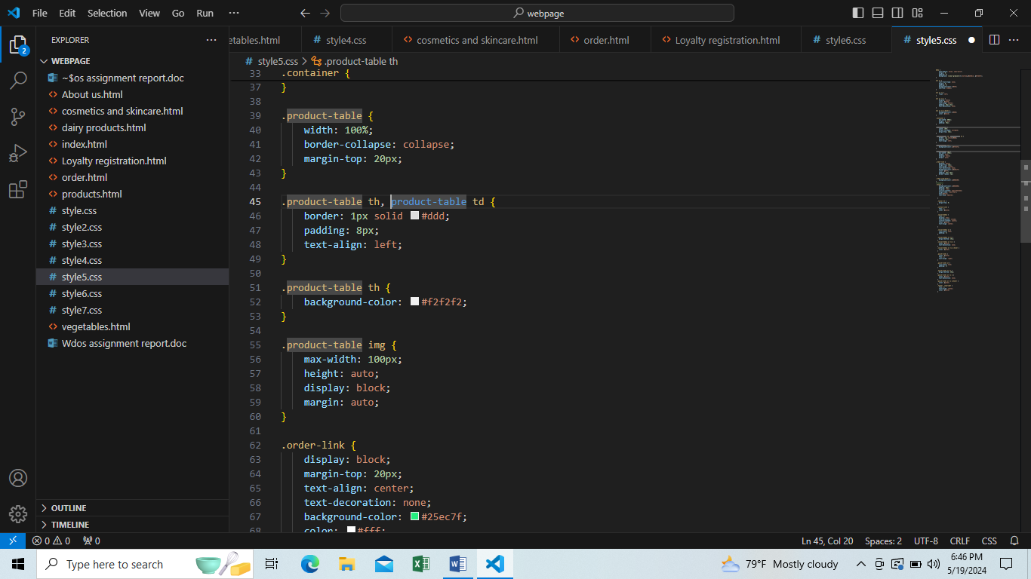 Missing fullstop in product table command
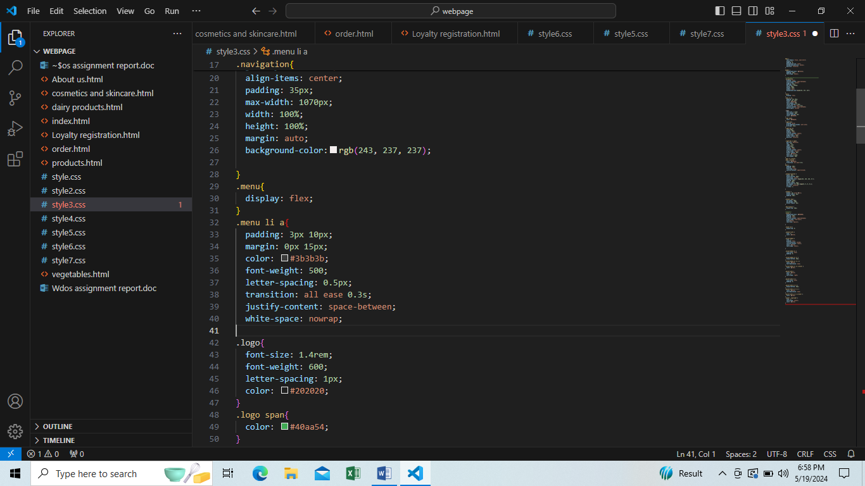 Missing curly brackets

- The images of my website didn’t appear once I uploaded the website in GitHub
- Corrected it by adding double dot and backslash to image path and renaming images to short names.
Wireframes
Homepage About us page Product page
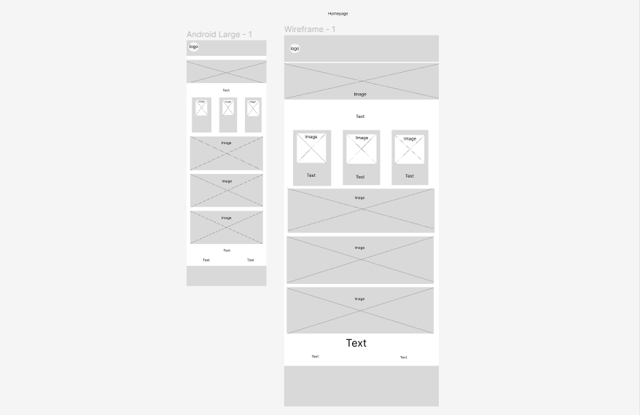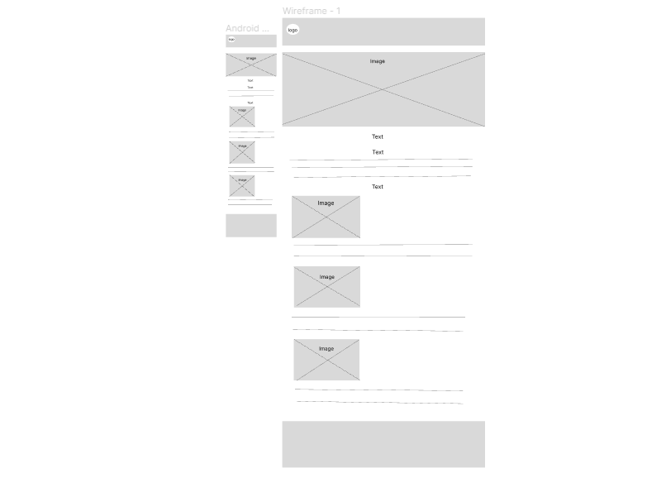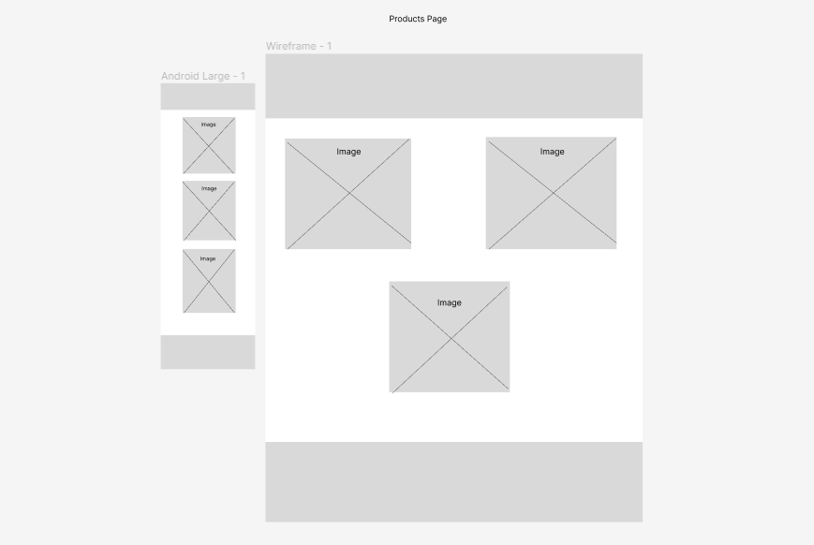
Dairy Products page Vegetables page Cosmetics and skincare page
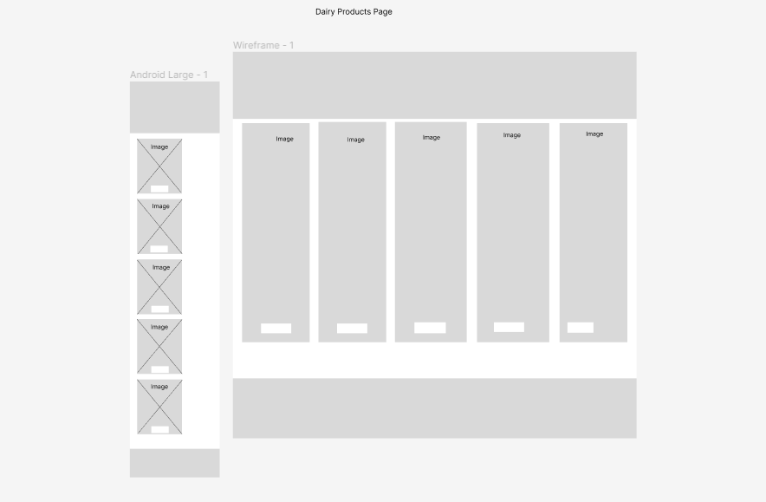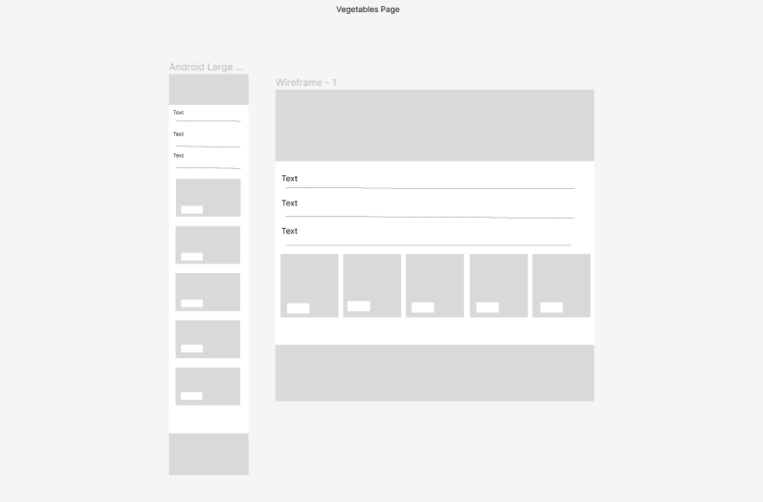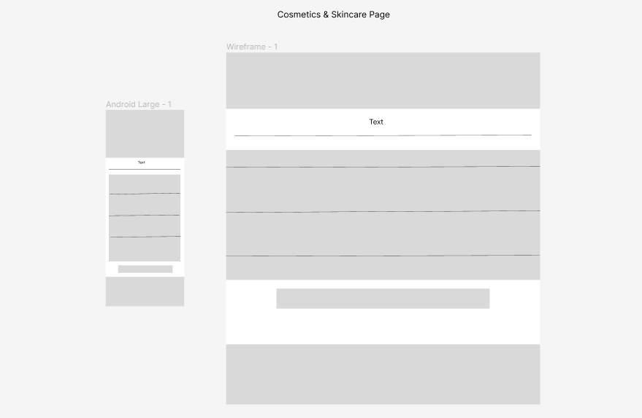
Loyalty Registration page Order page
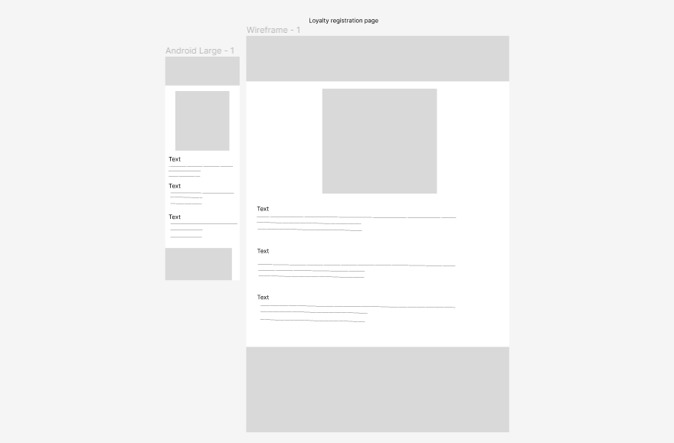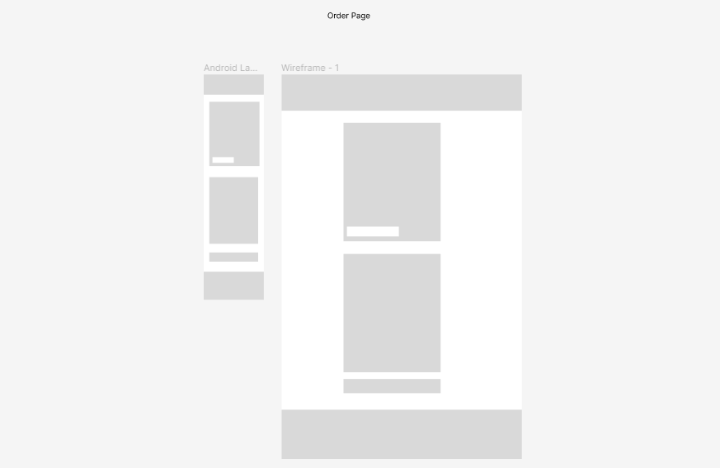
Learning Outcomes

- Improved cognitive understanding.

- Perceptions of interest in course, use of course materials, and active
learning.

- Understanding and identifying the skills required to design a website
while fulfilling the expected requirements.

- Time management.

- Testing a website and making necessary changes.

- Learning to describe the web page layout design techniques.

- Bringing up innovation within the given scenario.

- Problem solving skills.

- Analyzing the concept of responsive webpage design.

- Designing skills being enhanced

